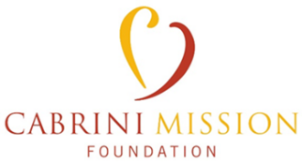
Education Grant Application Form

Personal Information:

Name:
[Students Full Name]

Parents Name:
[Applicants Parent or Parents Names]

Mailing Address:
[Address]
[Address]
[City]
[State/Province]
[ZIP/Postal Code]

Phone Number:
[Parents Phone Number]

Email Address:
[Parents Email Address]

Academic Information:

Educational Institution:
[Name of the School/must be a Catholic school]

School Address:
[Address]
[Address]
[City]
[State/Province]
[ZIP/Postal Code]

Expected Graduation Date:
[Date of Expected Graduation]

Academic Year:
[Year of Study (e.g., Grade Level or Freshman, Sophomore, Junior, Senior)]

Financial Information:

Financial Aid Received:
[ ] Yes
[ ] No
(If yes, please provide details)

Grants/Scholarships Applied for This Year:
[List any other grants or scholarships received in the current year]

Essay Questions:

1. In your own words please share the importance of Mother Cabrini’s Legacy and the Cabrinian Charism in the world today. (500 words or less)

2. The Cabrini Mission Foundation places a strong emphasis on a mind, body and soul well-rounded academic approach. Applicants are encouraged to showcase their participation in community service, extracurricular activities, and athletics. Please share your community engagement and or volunteer activities you have been involved in.

Supporting Documents:
Please attach the following supporting documents to your application:
Essay Question responses.
Transcript: A copy of your most recent academic transcript.
Optional: Additional Documents (other supporting materials)

Please note:
- Any awarded grant will be sent directly to the student’s school to offset the tuition balance.
- Student applications and submitted essays become the property of the Cabrini Mission Foundation

By signing below, I certify that the information provided in this application is accurate and complete to the best of my knowledge. I understand that any false statements may disqualify me from consideration for a Cabrini Mission Foundation Education Grant.

Student Signature: Parent Signature:

Date: Date:

